Outlier removal using z-score

If we want to remove outliers using z-score method then our column must be normally distributed.

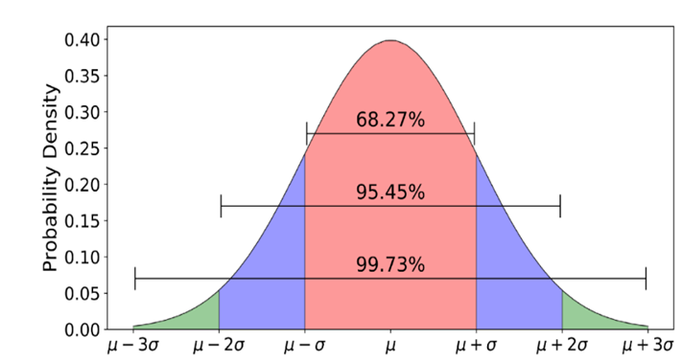

In normal distribution our data is lie in this range

- Z-score is calculated as (X - mean) / std deviation
- If the z-score is greater than 3 or less than -3 then we can consider it as an outlier.

Now how to treat outliers??

1. Trimming :
-> In this method we simply remove the outliers from our dataset. This method is simple and effective but it can lead to loss of data if we have a lot of outliers.

2. Capping:
-> In this method we replace the outliers with a certain value. This value can be the maximum or minimum value of the column or it can be a value that is calculated using some method like IQR (Interquartile Range) method. This method is useful when we have a lot of outliers and we don't want to lose data.

